Aws assignment 2

Step 1: Create Delivery stream

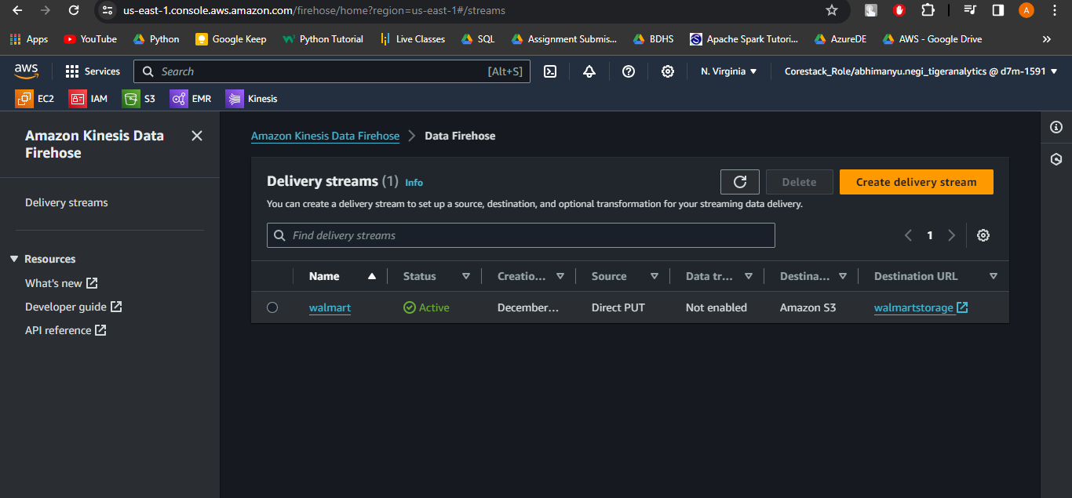

Step 2: LogGenrator file edit

Step 3: Configuring the agent

Step 5:

Validation after running the log generator file

